Job Application Tracking System - (Developer) - (Shortterm):-

# Team ID : LTVIP2023TMID11621

**Team Leader : V MOHAN KUMAR**

# Team member : V MURUGA RAJU

**Profile**

What is a profile?

A profile is a group/collection of settings and permissions that define what a user can do in salesforce. A profile controls “Object permissions, Field permissions, User permissions, Tab settings, App settings, Apex class access, Visualforce page access, Page layouts, Record Types, Login hours & Login IP ranges.

A profile can be assigned to many users, but user can be assigned single profile at a time.

# Create A Custom Profile

1.From setup , enter profiles in Quick Find box 2.Select profiles (Standard user).

1. Click clone.

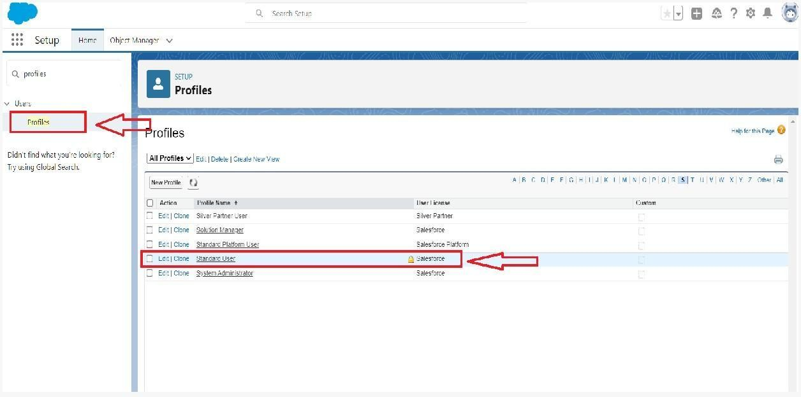

1. For Profile, enter Recruiter.

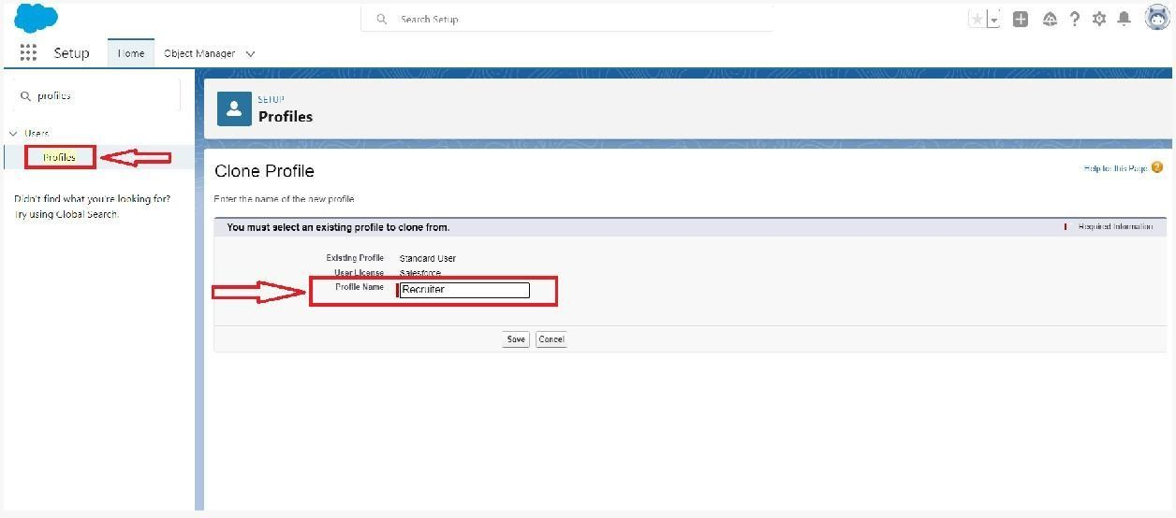

1. Click save.

# Create A Custom Profile-2

Create a profile with the profile name as “Sales Manager”.

1.From setup , enter profiles in Quick Find box 2.Select profiles (Standard user).

3.Click clone.

Follow the steps from above Activity

# Role

In Salesforce, roles are used to determine which users have access to certain data and functions within the system. They are also used to define the reporting hierarchy within an organization. Users with higher roles have greater access to data and more control over the system.

# Creation Of Role

1.From the Quick find box search for the role and click on the roles option 2.select the set up roles option

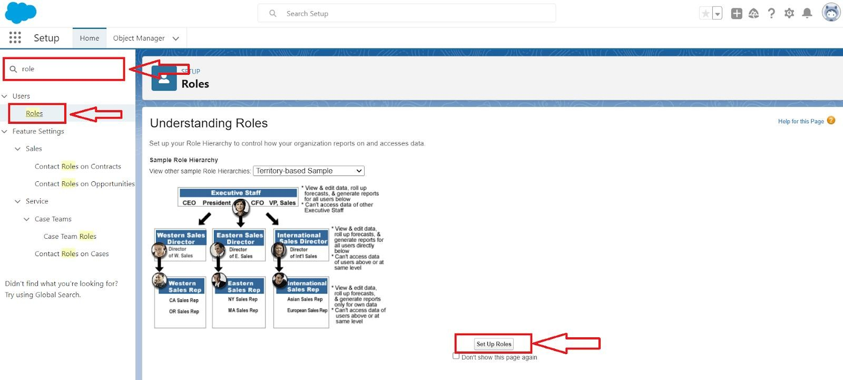

3.Below the CEO click on add role and enter the label name as a ” HR Manager ” and role name will be Automatically populated and click on save.

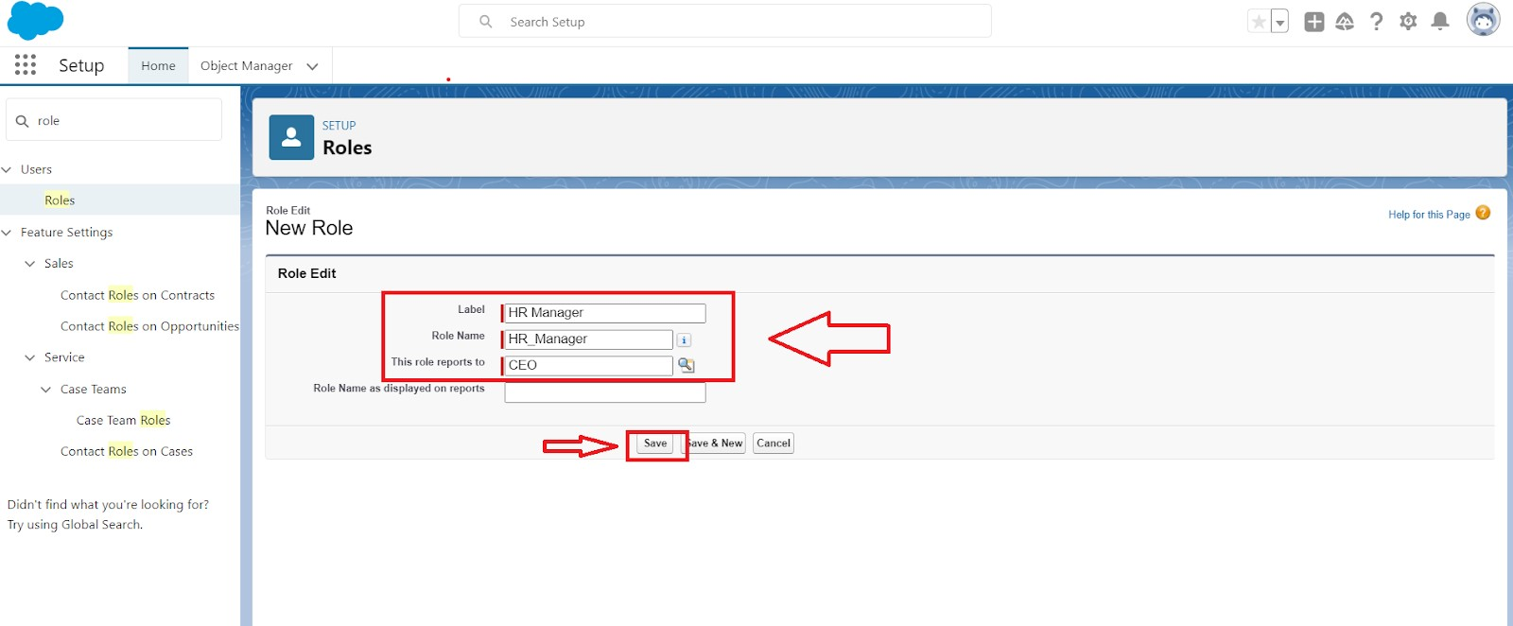



# User

**What is a user?**

A user is anyone who logs in to Salesforce. Users are employees at your company, such as sales reps, managers, and IT specialists, who need access to the company's records. Every user in Salesforce has a user account. The user account identifies the user, and the user account settings determine what features and records the user can access.

NOTE- As Salesforce license can only be used by 2 Users at a time in Dev Org, so If you don’t find salesforce license then deactivate a user who has salesforce license Or change the license type from Salesforce to any other.

# To Create A User

1.From Setup, enter Users in the Quick Find box, then select Users. 2.Click New User.

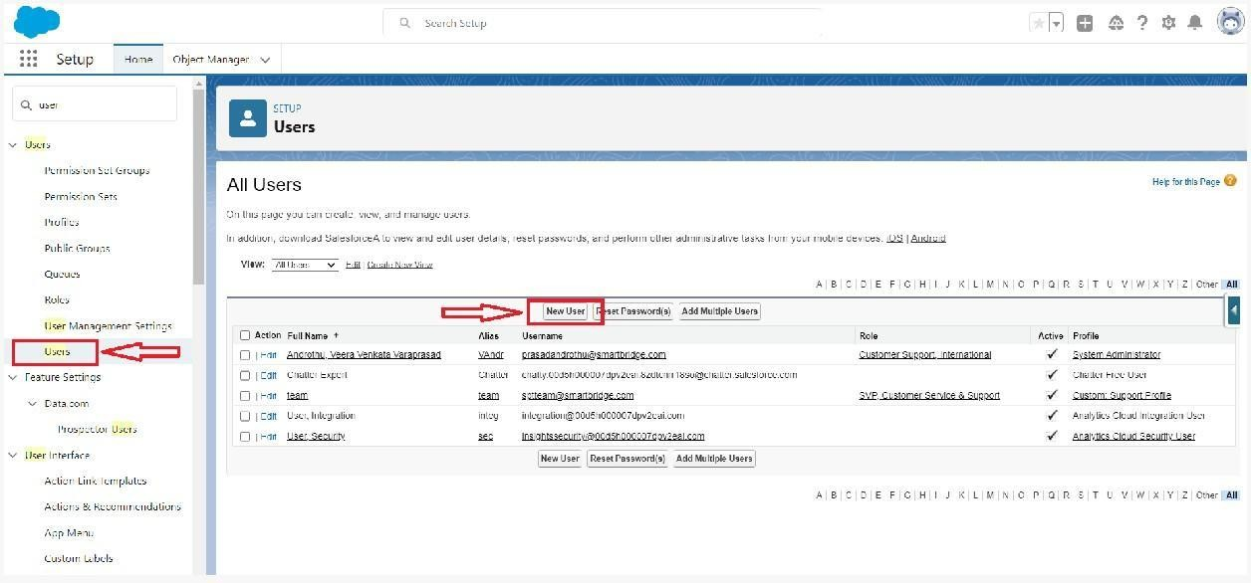

1. Enter First name as HR and last name as Manager.
2. Enter the user’s name and email address and a unique username in the form of an email address. By default, the username is the same as the email address.
3. Then create a new role HR Manager.
4. Select user License as Standard Platform User. 7.Select profile(Recruiter).

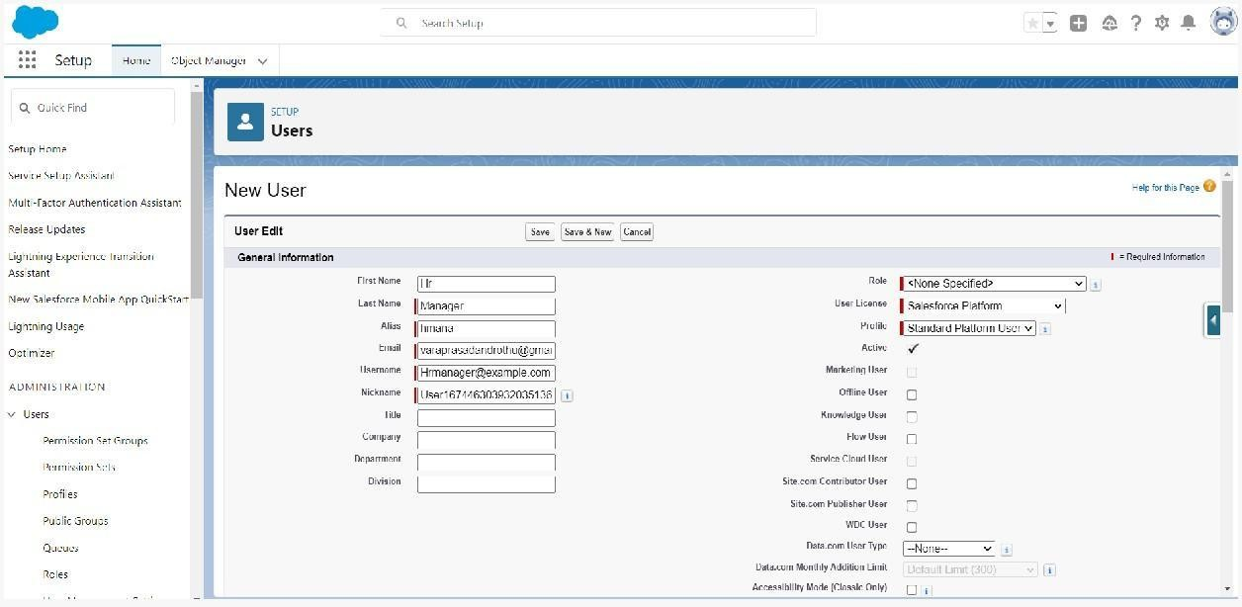

8.Click save

# Create Another User

Create a user with a username as “Ganesh Gelli”, and assign him the sales Manager profile. Follow the steps from above Activity